INDIAN SCHOOL AL WADI AL KABIR
TERM 1: Chapter 1- Sociology & Society
NOTES AND Q&A

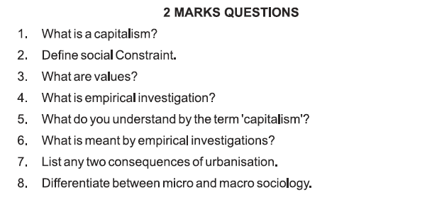
ANSWERS:
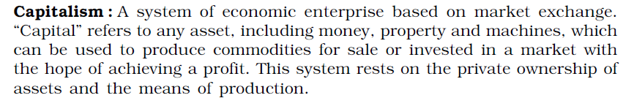
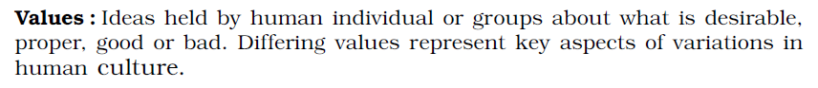

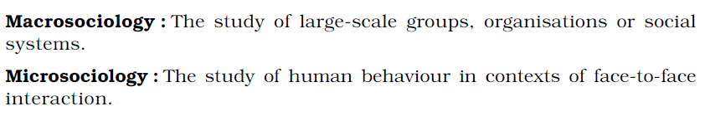
7. Urbanization involved an increase in the proportion of people living in towns and cities. Urbanisation occurs because people move from rural areas (countryside) to urban areas (towns and cities). In many parts of the world, industrialization resulted in urbanization. Two of its consequences were:
- poor living conditions of people who had migrated to cities in search of jobs and
- new significance of clock time as the basis of social organization
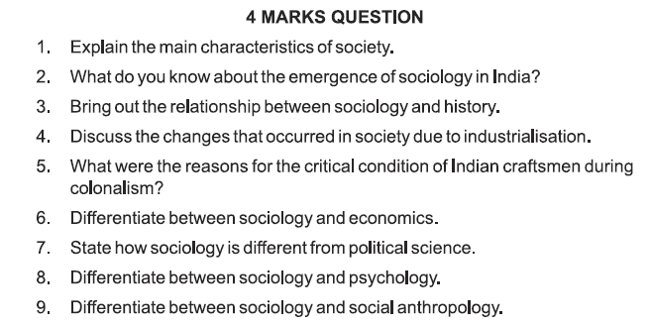
ANSWERS:
- The main characteristics of society are as follows:
-Society is a territorial group.
-Progeny: The members of a society came by means of human reproduction within the group of people.
-Culture: Society is always culturally sufficient.
-Independence: Society is permanent, self-contained and an integrated group. The members of a society are interdependent.

- Emergence of Sociology in India

- During the course of their rule in India, the British officials realized that for smooth administration, it was important that they acquire knowledge of Indian society and culture. This prompted the origin of Sociology in India.
- Western sociological writings about Indian society were sometimes misleading. For instance, the understanding and portrayal of the Indian village was unchanging. Many Indian scholars thus, took to sociological studies to close such gaps.
- The diversified nature of the Indian society in terms of region, language, religion, ethnicity, caste, etc. also led to the growth of sociology in India in connection with the discipline of social anthropology. This is a characteristic feature different from that of the western countries where both disciplines have been kept distinct from each other.
- Indian sociologist realized that the transformation process of contemporary Indian society is different from that of the western society. Modernity as understood in the western European society is the outcome of scientific process and democratic ideas. Whereas the same process of modernity was introduced in Indian society under the colonial regime.

- Discuss the relationship between Sociology and History.
Answer: Sociology tries to understand the social life of particular times only on the basis of historical influences whereas History is a compilation of the events of the past.
- History focuses on the study of the past, whereas Sociology shows interest in contemporary scene or recent past.
- History emphasises on the differences in the similar events but Sociology deals with the similarities in different events.
- Sociology takes help of history to understand modem society because sociologists can get social facts of ancient society from history.
- Changes in society due to industrialization
Ans: The Industrial Revolution began in Britain in the late 18th and early 19th centuries. It marked the beginning of the scientific age and led to changes in social lives of people.
- Before industrialization the rural sector was important. The chief occupation was farming and weaving. Society was hierarchical, status and class conscious. People worked according to their needs, factors like daylight and deadlines.
- Industrialization meant there was a systematic application of science and technology. Huge factories were set up for large-scale production of goods like textiles and iron and steel. New forms of economic activity gave rise to capitalism as the pursuit of profit was geared to markets in distant colonies.
- There was a dramatic change in social life as a new working class emerged. Farmers migrated to industrial cities, which were characterized by overcrowded housing, poor sanitation and general squalor.
Qs: In what ways did the Industrial Revolution lead to the birth of Sociology in Europe?
The Industrial Revolution began in Britain in the late 18th and early 19th centuries. It marked the beginning of the scientific age and led to changes in social lives of people.
- Before industrialization the rural sector was important. The chief occupation was farming and weaving. Society was hierarchical, status and class conscious. People worked according to their needs, factors like daylight and deadlines.
- Industrialization meant there was a systematic application of science and technology. Huge factories were set up for large-scale production of goods like textiles and iron and steel. New forms of economic activity gave rise to capitalism as the pursuit of profit was geared to markets in distant colonies.
- There was a dramatic change in social life as a new working class emerged. Farmers migrated to industrial cities, which were characterized by overcrowded housing, poor sanitation and general squalor.
- An indicator of this new society was the emergence of “clock time”. The tempo of work was set by the clock and calendar. Factory production meant that work began punctually and people worked in shifts for set hours and were paid according to what they produced.
- Karl Marx and Durkheim were appalled at the degradation of factory workers and became concerned with the scientific analysis of developments in industrial society. Sociology was born as a result of this as it was based on the understanding of “science of a new modern industrial world”.

The British Govt had a profound effect on the Indian economy in all policies implemented. The traditional structure of the economy has been completely modified and it has become a colonial economy that has been signed off for the needs of Britain's newly emerging industrial economy.
Reasons for the critical condition of Indian craftsmen during the colonial period were as follows:
- Under the colonial rule, the Indian artistic crafts which made the nation famous had collapsed. This was primarily because of the competition of products imported from Britain by the machine. The ability to produce massive products helped Britain flood the Indian market, particularly with cotton textiles, with cheap products.
- Many craftsmen were obliged to give up their ancient trades. The UK exported cotton-like "raw materials" from India. The Indian weaver therefore had to purchase these products at a higher price. As compared to machine made goods, this resulted in increased the cost of Indian crafts. In the English market, Indian goods also were subject to high tariffs, while British goods acquired "duty-free access" in the Indian markets.
6. Discuss the relationship between Sociology and Economics.
Answer:
1. Sociology studies the different parts of society as a whole whereas Economics studies only the economic part of society.
2. The viewpoint of sociology is extensive while economics is a special science related to the economic aspect of human beings.
3. The approach of sociology to study relationships is collectivistic whereas the perspective of economics is individualistic.
4. Sociology uses quantitative and numerical methods whereas economics derives facts using inductive and deductive methods.
5. Economic phenomena are constantly determined by all sorts of social needs and activities and they are constantly redefining, creating, shaping and transforming social needs and activity of every kind.
7.How Sociology and Political Science are related to each other?
Answer: Political science studies political institution such as state governments and its branches like legislative, executive and judiciary.
- Sociology studies power in terms of social context e.g. during elections.
- Political Science is restricted to study of formal organisation and institutions whereas sociology is concerned with study of behaviour of the people in power.
- Sociology focuses on social stress on the interpersonal relationship between political institution.
- The main task of a political scientist is to study the political behaviour whereas main task of sociologist is to develop knowledge that would explain both social and political behaviour along with the consequences of this behaviour.
- There are several areas of social life that need both the approaches e.g. implementing a law and its effect on people.
8.What is the relationship between Sociology and Psychology?
Answer:
Psychology is one of the closest subjects to sociology.
- Psychology focuses on the study of an individual’s mind, whereas sociology studies society.
- Psychology is the science of behaviour, mental processes, experience whereas Sociology is the study of social behaviour of man in society.
- Psychology is more interested in intelligence, learning, emotions, motivation, memory etc. Sociology is interested in relationships between family, marriage, kinship values and norms.
- Psychology studies about hopes and fears of individuals, sociology studies about social institutions in an organised way.
- Social psychology bridges the gap between two subjects and studies how individuals behave collectively in society.
9. How Sociology is related with Social Anthropology?
Answer: Relationship between Sociology and Social Anthropology-
- 1. Types of Society: Sociology emerged as the study of modern, industrial complex societies while Social Anthropology emerged as the study of primitive, simple and small-scale societies.
The anthropologists of the past documented the details of simple societies apparently in a neutral scientific fashion. In practice, however, they were constantly comparing those societies with the model of the western modern societies as a benchmark.
- 2. Scale of study: Social anthropology tended to study society (simple societies) in all their aspects, as a whole. In so far, as they specialized, it was on the basis of area. For example, the Andaman Islands. Sociologists study complex societies and
would therefore often focus on parts of society like the bureaucracy or religion or caste or a process such as social mobility.
Methods of Study: Social Anthropology has been associated with the ethnographic methods of participant observation. It is characterised by long field work tradition, living in and with the community being studied for a long time and learning their language.
Sociologists have often relied on survey methods and quantitative data using statistics and the questionnaire mode.
Convergence of Sociology and Social Anthropology:
- Today the distinction between a simple society and a complex one itself needs major rethinking. India itself is a complex mix of tradition and modernity, of the village and the city, of caste and tribe, of class and community.
- Consequently, there is a coming together of sociology and social anthropology in India. There have been fruitful interchanges between the two disciplines and today often methods and techniques are drawn from both.
- On the other hand, Sociology too has been using quantitative and qualitative techniques, macro and micro approaches for studying the complexities of modem societies.

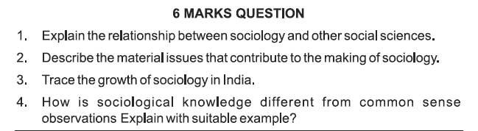
ANSWERS:
2. Discuss the revolutionary changes in 19th century Europe that led to the emergence of Sociology or Material issues that contributed to the making of sociology in Europe.
Answer: Sociology was born in 19th century Europe as a result of the revolutionary changes brought about by the Enlightenment, the French Revolution and the Industrial Revolution.
- Medieval Europe was a feudal society. The church dominated all spheres of society including matters of state and the king was regarded to be divinely ordained to rule over his people as he deemed fit. Gradually people began to question every aspect of life including the authority of the church and the monarchy.
- This led to the Age of Enlightenment, which laid great emphasis on reason and
rationality. There was a growing conviction that the methods of natural sciences could be extended to study affairs of human society. E.g., Poverty began to be seen not as a natural phenomenon but as a social problem caused by exploitation and human ignorance. Hence poverty could be redressed and resolved.
-Enlightenment values of intellectual and political freedom found expression in the French Revolution of 1789. This revolution popularized the notion that all individuals possessed the right to liberty, equality and fraternity. The revolution ended monarchy and ushered in democracy. The age of feudalism ended and birth-based privileges were abolished.
-The Industrial Revolution began with the advancement of science and technology. It brought in capitalism as industry became economically very important. Farmers left their holdings to work in factories in the industrial cities of Britain. The features of society changed and the working class became important. Once again society was transformed as a new social order emerged.
-People like Comte, Marx and Durkheim tried to make sense of these revolutionary changes and restore order to chaos. Their efforts helped the emergence of Sociology, as they believed that the scientific study of Sociology would help in the reconstruction and reorganization of a strong and healthy society.
3. Why is the study of the origin and growth of sociology important? Or growth of Sociology in India
Answer: The study of origin and growth of societies are important in sociology to understand several personal and social issues. England was the center of the industrial revolution. The understanding of how urbanization or factory production influenced all modern societies is very important.
Sociology of India reflects the origin and growth of people, social institutions and their problems. Indian history is full of imperialistic invasions. In India there has been a long past of feudalism, capitalism and colonization.
Indian history related to political, social or cultural domains is written by foreigners and therefore it is far from truth. Basically, it is biased. Therefore, Sociology of India is also biased. Presently Indian society can be understood in its complexity of tradition which is influenced by Turks, Mongols, Kushan, Afghans and Britishers and the influence of the modern world. Indian sociology is a complex product of its history.
Therefore the study of the origin and growth of society is important for sociology.

4. As we know, the two terminologies of sociology and common sense are not common. Let us understand the difference between sociology and common sense in detail.
Sociology | Common Sense
Sociology is a more logical approach to any cause or change. | Common sense stems from what we think and can change from person to person.
Sociology uses a casual pattern of explanation. It tries to investigate the cause-effect or vice versa. | Common sense has no causal explanations. It is a belief that is innate and true to specific sections of society.
Sociology is purely based on facts that are practical and lack hindrance. | Common sense is driven more towards stereotypical beliefs. For instance, most people say it’s common sense that pink is a female color. However, it is not true.
There is an empirical approach, testing, and explanation that happens in sociology. | In common sense, there is no room for empirical testing or explanation to beliefs.
Sociological beliefs are generalized. They are done and decided for the betterment of society and are followed too. | Common sense can be more personal. It might stand true to a certain section of the population. However, generalization is not possible.
The dimension of sociology is change-oriented. Every rule or law or policy that goes out, is intended to make a change in the existing society. For instance, the government asks shops to cut down plastic use due to increasing global warming. Here, the government is suggesting a change for society. | The dimension of common sense is status-quoism. In this, common sense is only meant to convey the existing state. For instance, there is a flood in Assam, which is status-quoism. Common sense portrays the same; it does not suggest the next action.
These points explain the difference between sociology and common sense. The advent of sociology and common sense are the same. Both of them state the facts. However, sociology is change-driven, and common sense can be static. Therefore, sociology and common sense differ by nature, aim, and characteristics.

The general population would consider sociology and common sense to be the same. In layman’s language, both sociology and common-sense sound the same. However, both these terminologies differ in various aspects. The difference between sociology and common sense is based on the aim, purpose, and characteristics. Sociology is more about understanding society through a logical approach. Common sense stems from personal experiences and can only be relevant to a particular section. Common sense states only the existing conditions in society.
In some cases, sociology and common sense can work together. For instance, common sense can indicate an existing problem. And the sociological aspects can help us know what changes can be made. Therefore, sociology and common sense may sound the same, but they hold varied relevance in society.

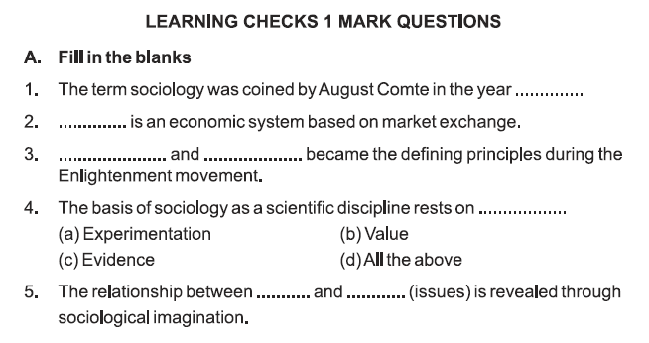
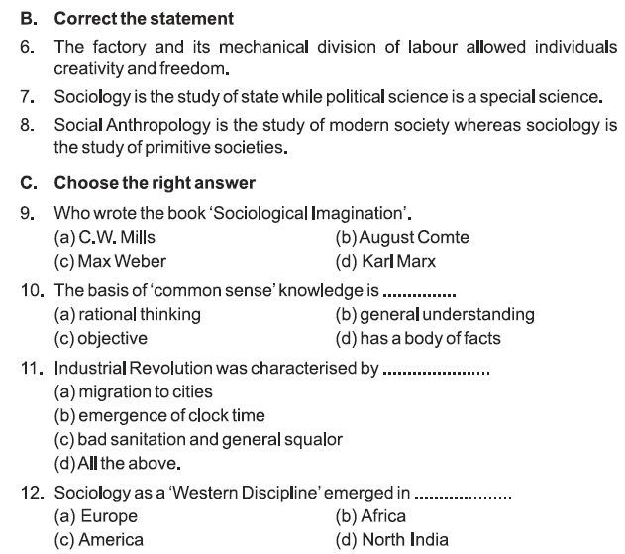
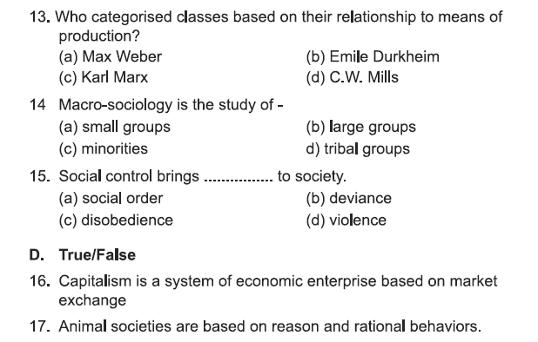
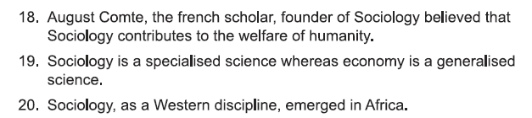
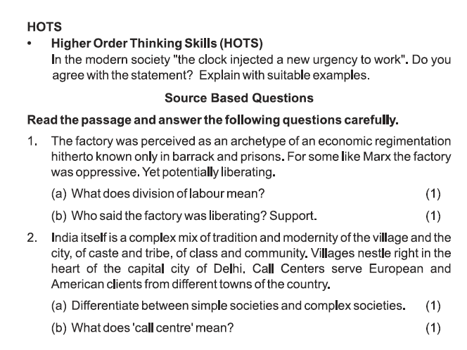EXTRA QUESTIONS:
1) What is Sociology?
- Sociology is a scientific and comprehensive study of society.
- The very origin of the word ‘Sociology’ comes from the Latin word ‘Socius’ (companion) and the Greek word Ology (study of), to indicate its nature as a hybrid discipline.
- August Comte, a French philosopher coined the term Sociology in 1838 and called it the science of human associations. He is known as the ‘Father of Sociology’. The contributions of Durkheim Spencer and Max Weber are significant to develop Sociology as a separate discipline.
- By and large Sociology as a scientific discipline has certain characteristics. It is a social science, not a natural science, which studies social groups and social relations. It is a categorical science, not a normative science because it deals with ‘what is’ instead of ‘Who ought to be’.
- Sociology is a pure science, not an applied science. It simply collects the knowledge about human society. It is an abstract science not a concrete science. It simply deals with the design and norms and is interested in the fact that despite the differences in their origin and culture people live in a common human society.
- Sociology is a science of generalization and not specialization. It simply makes generalizations about human groups, social actions, societies and their structure. Sociology is both a rational and empirical science.
- Sociology analyses society. It focuses on the emergence of society. It deals with major social units and their dynamics.
Short Answer Questions:
1) Discuss the pluralistic perspective of a society.
Answer:
Society can be understood better as a group of people who are interacting, interdependent, have a structure and follow a similar cultural pattern. Each society is unique. Society includes similarities, diversities, inequalities because in the society each individual has his own personal values and ideals. Individuals live in a society.
Write interesting terms from Page 8-10 from Chapter 1 (Sociology and Society) after reading it.
Theological, line of descent,
Answer in detail:
1) Is sociology a science?
Answer: Sociology is a science as it involves objectives and systematic methods of investigation and evaluation of social reality in the light of empirical evidence and interpretation.
It is not a natural science because human behaviour is not exact and varies from person to person.
Sociology is a categorical science because it relates to “what is”. It is a pure science because sociology collects the knowledge about human society only and is not concerned with its application. Sociology is an abstract science because it studies the design and norms of the society. It is a science of generalisation. It provides understanding about groups, social actions, subject matter and structure. Sociology presents general principles related to social interaction so it is a general science. Sociology is a science because it uses scientific methodology. It uses method of observation and believes in theory of causation and objectivity.
2) State main features of Sociology.
Answer:
• Sociology is a social science.
• It is a pure science, not an applied science.
• It is a categorical science, not a normative science.
• Sociology is a general science.
• It is both rational and empirical science.
• Culture, social organisation, social institution and social structure are the subject matters of sociology.
• Sociology is a science of generalisation rather than specialisation.

